Report By: Jiadong Hong

Total: ____/50
Teammates: Di Wu
Lab TA: Yunze Shi

Part I. ___/8

State Space Model Representation of H₁(s) ___/8
Compare the plots of y_dot and y obtained in Part 1 of the lab with the plots previously made for the prelab. Why are they identical? Attach plots – if your prelab plot was wrong, fix it and attach the corrected plot.
These are the plots of the prelab:
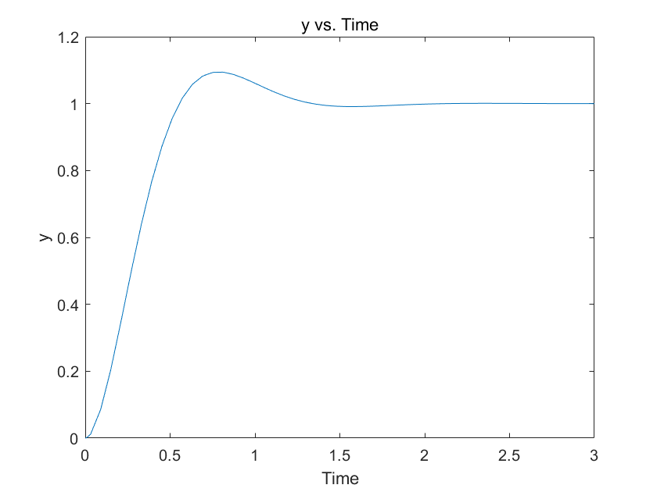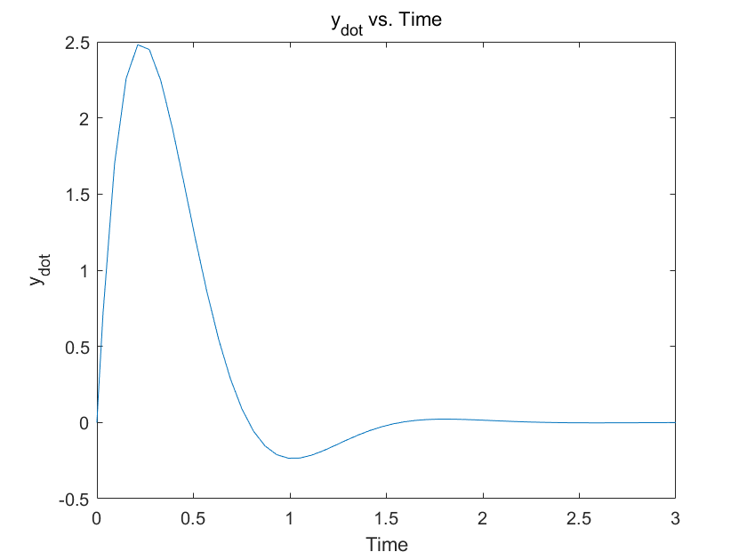
These are the plots of part 1:

As you can see that they are exactly identical.

Part II. ___/22

Effects of a Zero on M_{p}, t_{r}, and t_{s}. ___/2
Fill the table and attach plot for part II.

Property | No Zero  H₁(s) | H₂(s) with Zero at s = -30 | H₂(s) with Zero at s = -3 | H₂(s) with Zero at s = -1.5 | H₂(s) with Zero at s = 1.8 | H₂(s) with Zero at s = 18
M_{p} % | 9.40% | 9.63% | 41.05% | 114.7% | 19.54% | 9.77%
t_{r} (s) | 0.36 | 0.37 | 0.13 | 0.057 | 0.21 | 0.36
t_{s} (s) | 0.99 | 1.01 | 0.85 | 1.38 | 1.34 | 1.10

Table 1: Effects of Zero

Discuss the Effects of a LHP Zero ___/4
Explain how M_{p}, t_{r}, and t_{s} are affected by the zero’s location. When can the zero be ignored?

If zero lies within the open left half-plane, the overshoot (M_p) will rise, the rise time (t_r) will decrease, and the settling time (t_s) will extend. When zero is situated at a considerable distance from the imaginary axis, the impact of the zero can be negligible.

Effects of a Non-minimum Phase (RHP) Zero ___/2
What is unique in this situation?

Zeros located in the right half-plane will result in a response characterized by undershooting.

Decomposition of H₂(s) __/14
Take H₂(s), set ζ to the value found in the prelab, and separate the numerator into two terms so that H₂(s) is a sum of 2 fractions. Discuss how this decomposition helps to explain the effect of the zero location. In particular, discuss what each term represents. Also discuss α’s effect. Which term dominates as α approaches 0? As α approaches ∞? What happens when α is negative?

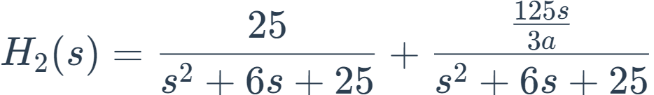
The first term signifies the impact of the original transfer function without the additional zero, while the second term represents the effect of the additional zero. As α approaches 0, the second term grows significantly and becomes dominant, indicating that the additional zero has a dominant influence on the system. When α approaches ∞, the second term approaches zero, and the first term takes precedence, suggesting that the effects of the additional zero can be disregarded. If α is negative and approaches 0, the transfer function becomes negative, resulting in an undershoot in the response.
\

Part III. ___/20

Effects of an Extra Pole on M_{p}, t_{r}, and t_{s}. ___/2
Fill the table and attach plot for part III. Attach Plots.

Property | No Pole  H₁(s) | H₃(s) with Pole at s = -30 | H₃(s) with Pole at s = -3 | H₃(s) with Pole at s = -1.5
M_{p} % | 9.40% | 9.27% | 0% | 0%
t_{r} (s) | 0.36 | 0.38 | 0.72 | 1.44
t_{s} (s) | 0.99 | 1.04 | 1.03 | 2.19

Table 2: Effects of Extra Pole

Discuss the Effects of an Extra Pole ___/4
Explain how M_{p}, t_{r}, and t_{s} are affected by the location of the additional pole. When can the extra pole be ignored?

An extra pole within the open left half-plane will decrease the overshoot (Mp), extend the rise time (tr), and prolong the settling time (ts). An additional pole that is significantly distant from the imaginary axis can be disregarded due to its minor influence. However, if there is an additional pole in the right half-plane, it will render the system unstable.

Decomposition of H₃(s) ___/14
Take H₃(s), set ζ to the value found in the prelab, and perform a partial fraction expansion to make three terms in the form of the expansion on page 18 in the lab manual. Determine the values of k₁, k₂, and k₃. Discuss how this decomposition helps to explain the effect of the location of an additional pole. In particular, discuss what each term represents. Also discuss α’s effect. Which term dominates as α approaches 0? As α approaches ∞?

The initial two terms depict the influence of the supplementary pole, while the third term signifies the impact of the original transfer function in the absence of the supplementary pole. As α approaches 0, both the second and third terms tend toward zero, and the first term takes precedence, signifying the overriding influence of the additional pole on the system. Conversely, as α approaches ∞, the first and second terms tend toward zero, and the third term becomes predominant, indicating that the effects of the pole can be disregarded.

Attachments (4)
- Plot from PreLab
- Plots for Part I, II and III.
  - Part 1
  - Part 2
